**DAILY ONLINE ACTIVITIES SUMMARY**

|  |  |  |  |  |  |  |  |
| --- | --- | --- | --- | --- | --- | --- | --- |
| **Date:** | **24/05/2020** | | | | **Name:** | **Varsha H Shetty** | |
| **Sem & Sec** | **8th B** | | | | **USN:** | **4AL16CS117** | |
| **Online Test Summary** | | | | | | | |
| **Subject** | | **No test** | | | | | |
| **Max. Marks** | | **No test** | | **Score** | | **No test** | |
| **Certification Course Summary** | | | | | | | |
| **Course** | AWS lambda foundations | | | | | | |
| **Certificate Provider** | | | **AWS** | **Duration** | | | **60 minutes** |
| **Coding Challenges** | | | | | | | |
| **Problem Statement::** | | | | | | | |
| **Status: COMPLETED** | | | | | | | |
| **Uploaded the report in Github** | | | | **YES** | | | |
| **If yes Repository name** | | | | **Varsha-Shetty** | | | |
| **Uploaded the report in slack** | | | | **YES** | | | |

Online Test Details: no test

Certification Course Details:

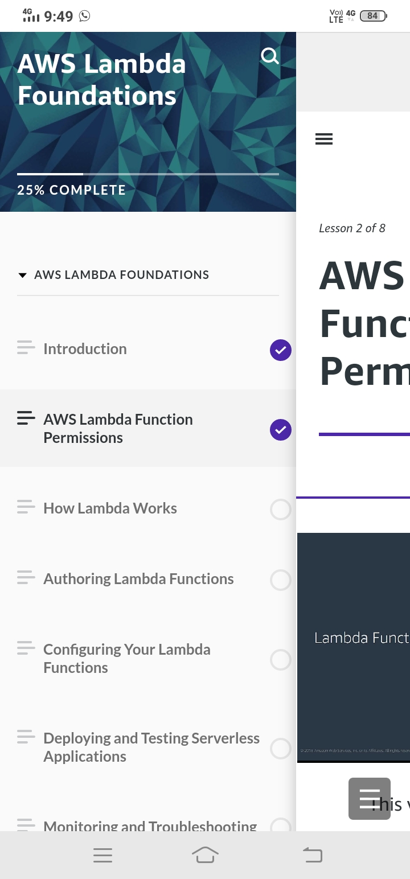

#### AWS lambda foundations

Coding Challenges Details

Cheeku is ill. He goes to Homeopathic Doctor - Dr. Thind.

Doctor always recommends medicines after reading from a secret book that he has. This secret book has recipe to cure any disease. Cheeku is chalak. He wants to know if Doctor is giving him correct medicine or not.

So he asks Doctor 2 questions -

Length of name of Book.

Number of pages in the Book.

Cheeku will take medicine from him only if Length of name of Book is lesser than or equal to 23 and number of pages in book is between 500 to 1000.

Otherwise he will not take medicine from this Doctor.

Help Cheeku decide. Print "Take Medicine" if he should take medicine from doctor. Else print "Don't take Medicine".

Input:

2 integers-

First denoting length of Secret Book.

Second is number of pages in Book.

Output:

If Cheeku should take medicine, print - "Take Medicine"

Else print - "Don't take Medicine".

SAMPLE INPUT

10 600

SAMPLE OUTPUT

Take Medicine

Explanation

10 is less than 23.

600 is between 500 and 1000.

#include<stdio.h>

int main()

{

char s[24];

int n,length=0,i;

for(i=0;i<s[i];i++)

{

scanf("%d",&s[i]);

}

length=strlen(s);

scanf("%d",&n);

if(length<=23&&n>=500&&n<=1000)

{

printf("Take Medicine");

}

else

{

printf("Don't take Medicine");

}

}